Final Website Planning Project

Bryan Liem

Web Development I

March 24, 2024

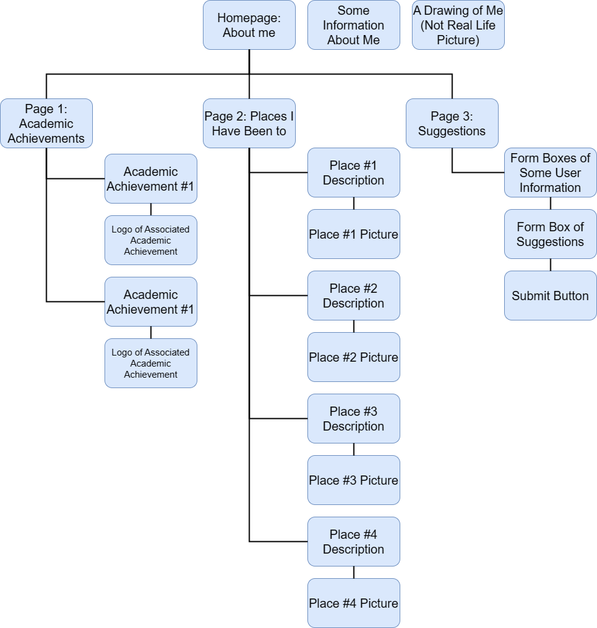 For my final website planning project, I will be creating a personal portfolio of myself that should include a brief description of me in the homepage, a page of current academic achievements, a page of places that I have been, and a page that should function as a suggestions page where people suggest things that I should “add” into the site. The site should have many uses of CSS including styled web forums and animations. For the site map below, I am not really sure how specific the elements of the pages are, and you may think that some of the elements in the site map are too generic. For images that I will be using, I will be using images that are taken by myself, along with some logos associated with the establishments that I earned academic achievements in.